**WEEK 4 TASKS**

**AIMEN HASHMI**

**App Name: TaskNest**

**Onboarding 1: Introduction with app name, a tagline emphasizing productivity, and a simple illustration.**

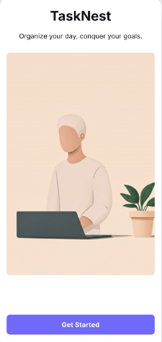

**Onboarding 2: Highlight key features with short descriptions and accompanying illustrations, such as task management and focus timer.**

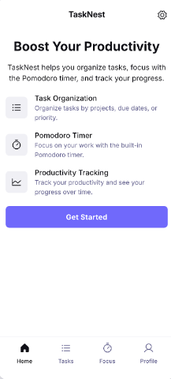

**Onboarding 3: Call to action for signup/login, with a welcoming message.**

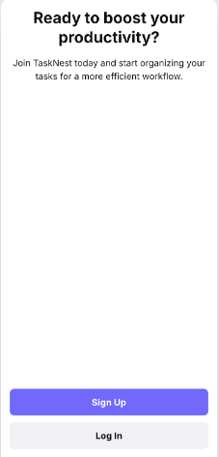

**Login/Signup: Options to log in for existing users or sign up for new users, using email/password or social login buttons styled with brand colors.**

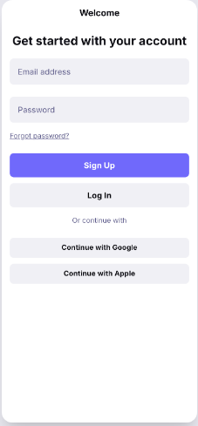

**Calendar View: Full-screen calendar showing a month view with dots or color indicators for days with tasks. Tapping a day reveals tasks scheduled for that day.**

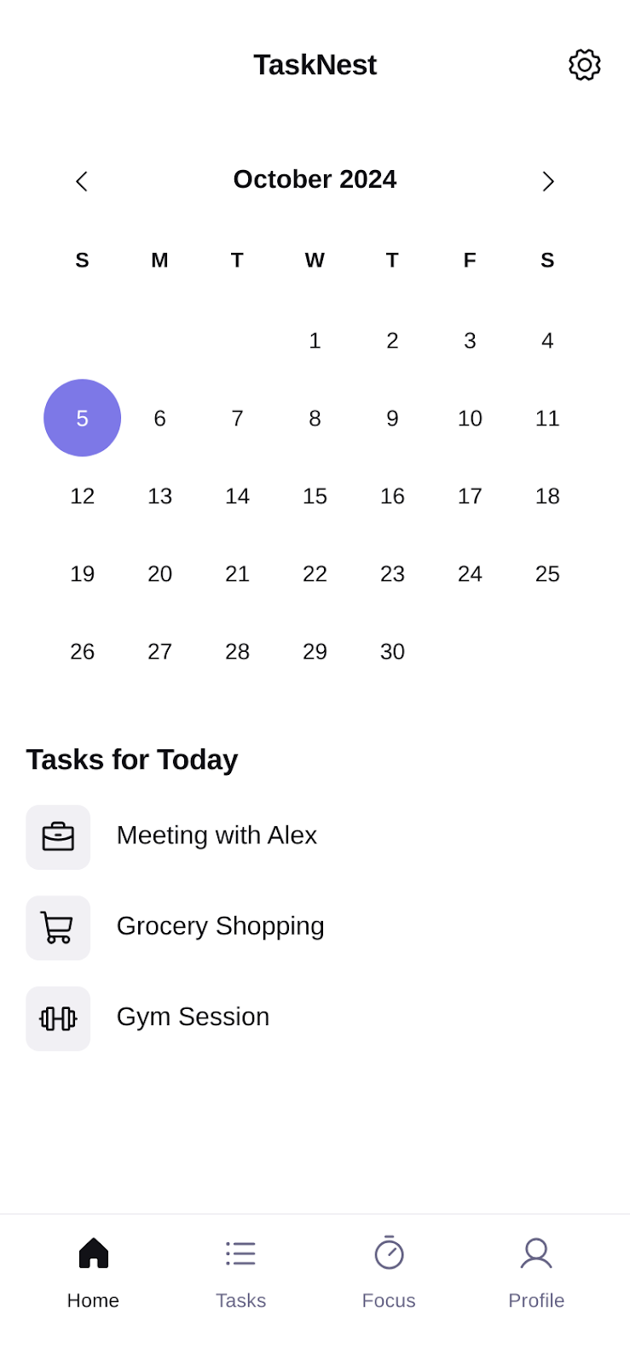

**Productivity Stats: Displays user productivity over time with bar charts for completed tasks per week/month and pie charts for task categories or priority distribution.**

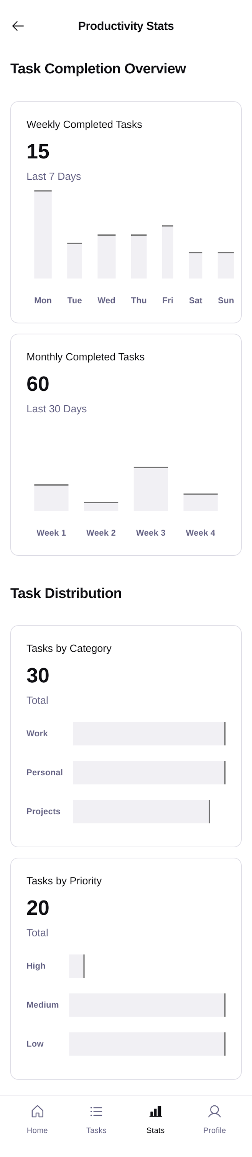

**Settings: User profile information at the top, followed by options for dark mode toggle, notification settings, app feedback, and account management.**

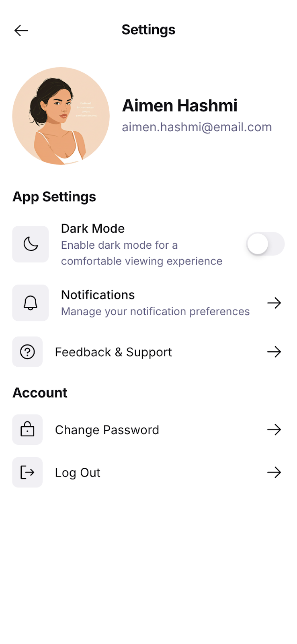

**UI/UX KIT**

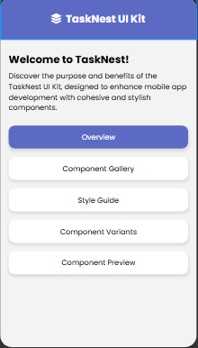

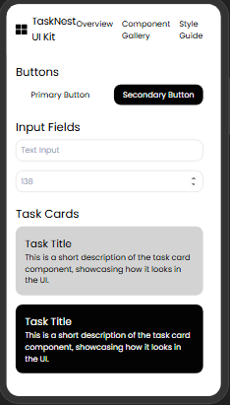

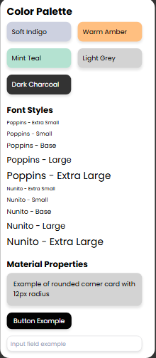

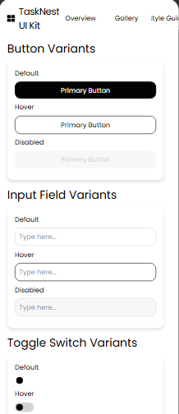

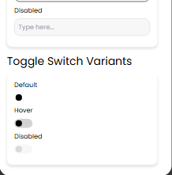

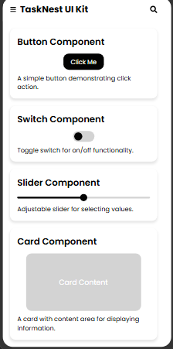

**WEB LAYOUT**

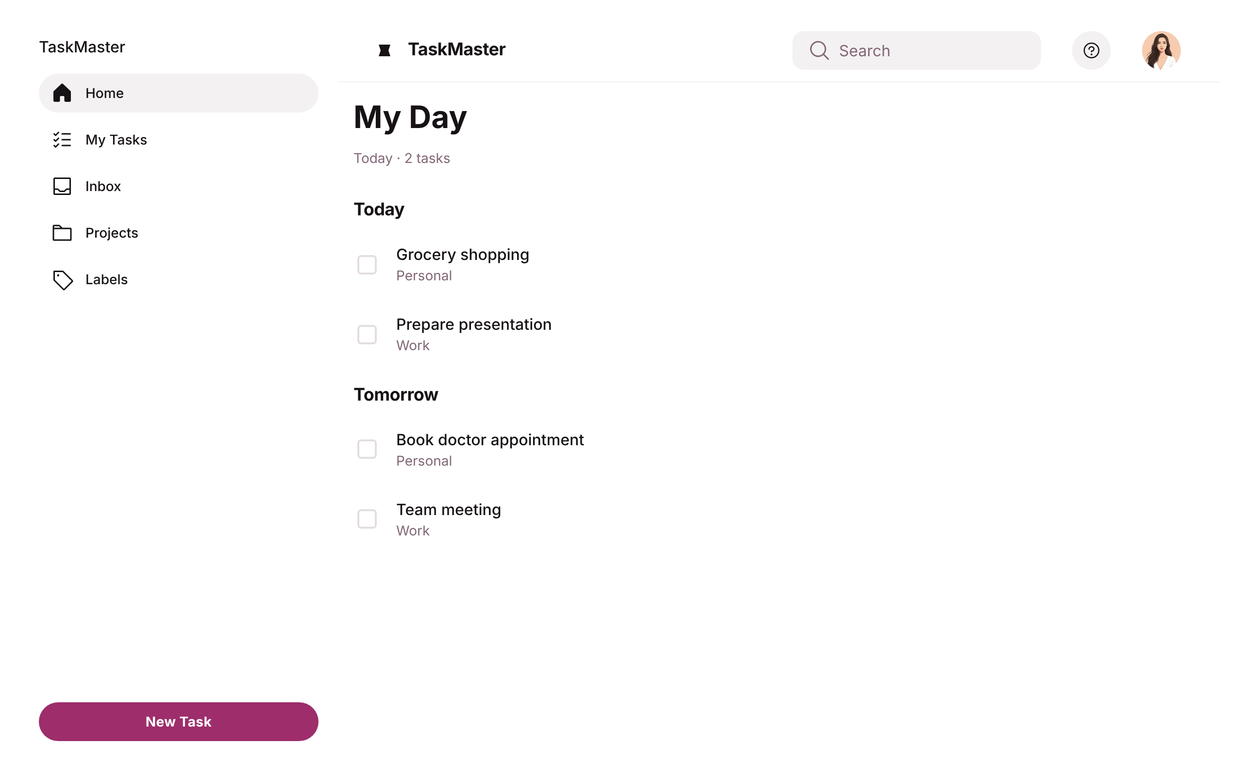

**ANIMATIONS AND TRANSITIONS**

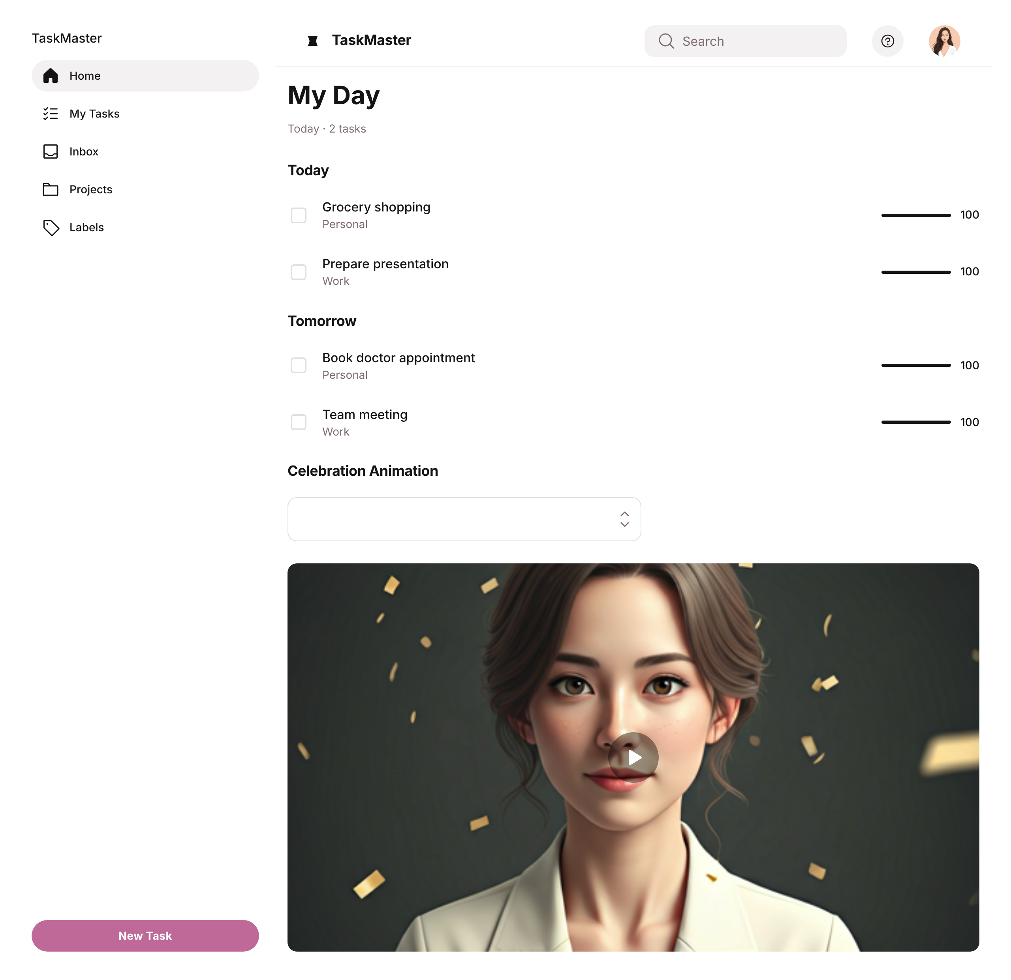

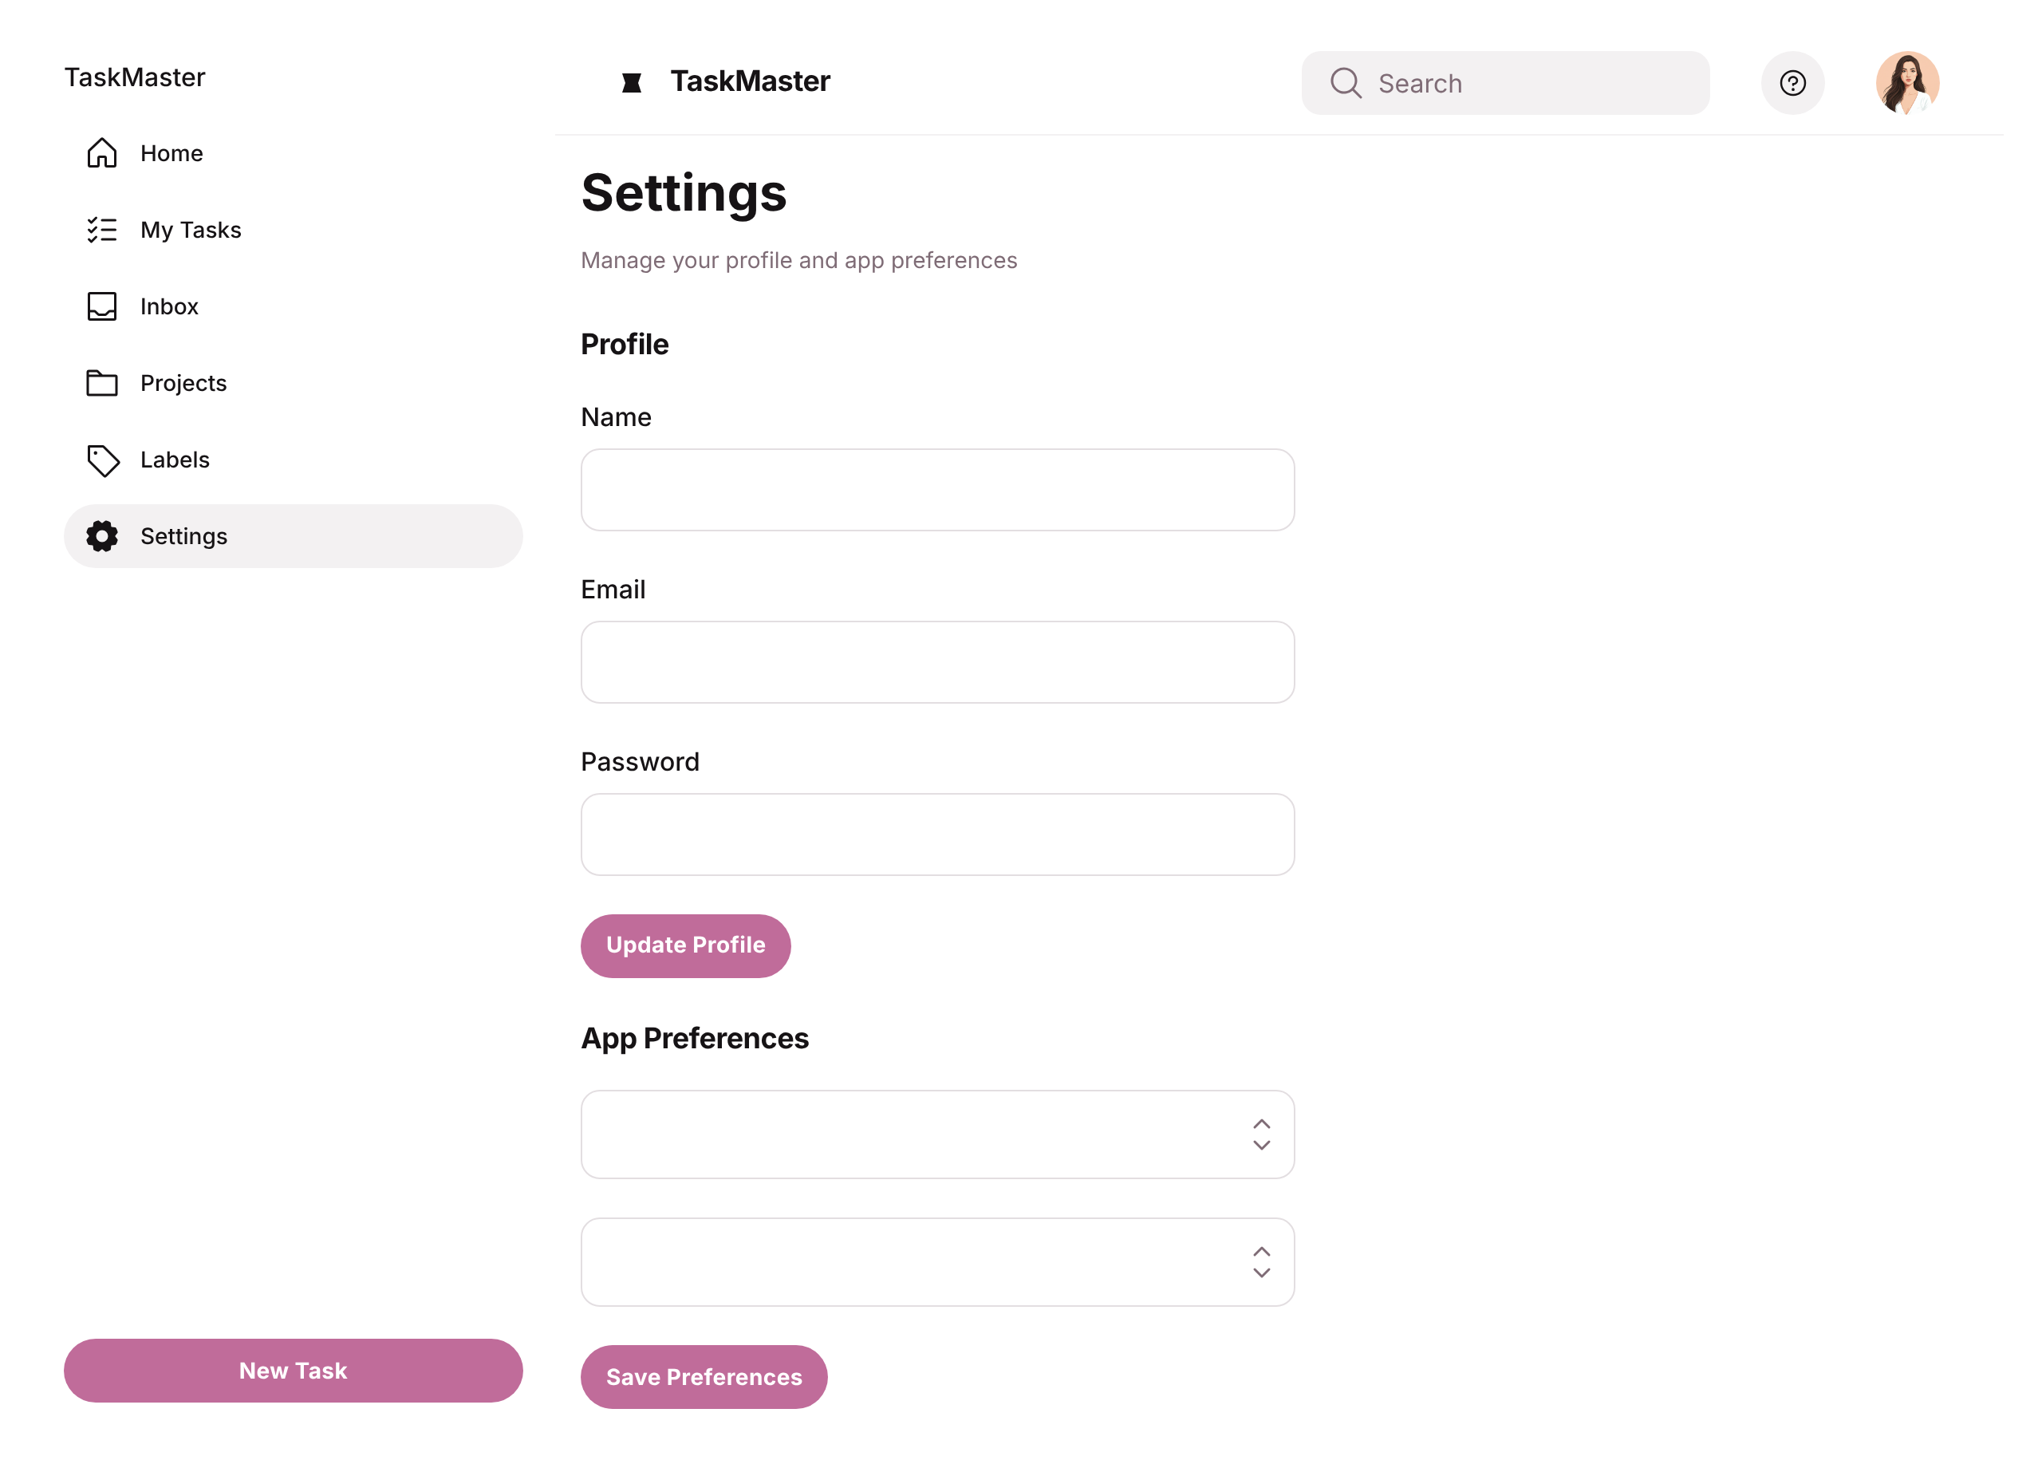

**END OF DOCUMENT**